January-March 2024

Dear Praying Friend,

We arrived in Saint Joseph Missouri on January 17th in a U-haul with our car towed behind. It was a very cold reception with snow everwhere! It’s been a real change for us. We were able to move things into our house the next day. We joined Eastside Baptist Church that Sunday. The kindness of Pastor Corbello and the church has been a great blessing. This month the Pastor asked us to start a choir and I’ve had quite a few opportunities to teach and preach. I pass out tracts to people I meet and my neighbour is coming to the men’s breakfast with me. We are getting to know our neighbours and Doyla has already taken a meal to one.

We feel like now, as much as ever, we need you to pray for us! It is a very strange time for us after 45 years in Australia. We hope to take some time for recovery and for family. We are trusting the Lord to provide. Thank you to those who continue to support us.

Stephen has recovered from his injuries but has not yet been approved to drive. They still aren’t sure what caused him to pass out, so are hesitant to have him be-hind the wheel yet. Please keep him in prayer. Also, for the church there, Fellowship Baptist Church and Pastor Agatep. God is blessing his ministry.

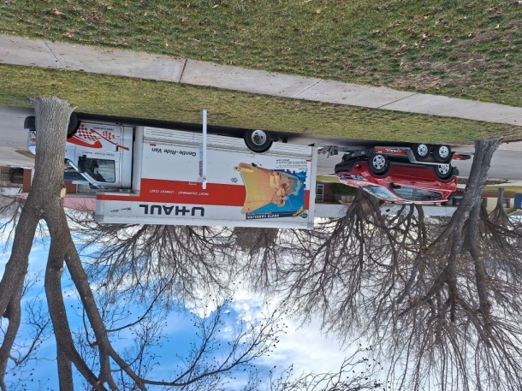 If we can be of any service please don’t hesitate to ask. We can be reached at 575 291 4177 or 1909 N. 32nd St. Saint Joseph MO 64506.

Thank you and God bless you!

Bill and Doyla Bramblet